Assignment - 2

Data Visualization and Pre-processing

Assignment Date | 21 September 2022
Student Name | Nishanthini S
Student Roll Number | 921319104136
Maximum Marks | 2 Marks

import numpy as np
import pandas as pd
import seaborn as sns
import matplotlib.pyplot as plt

Load dataset
df=pd.read_csv('/content/Churn_Modelling.csv')
df.head()
RowNumber CustomerId Surname CreditScore Geography Gender Age \
0 1 15634602 Hargrave 619 France Female 42
1 2 15647311 Hill 608 Spain Female 41
2 3 15619304 Onio 502 France Female 42
3 4 15701354 Boni 699 France Female 39
4 5 15737888 Mitchell 850 Spain Female 43
Tenure Balance NumOfProducts HasCrCard IsActiveMember \
0 2 0.00 1 1 1
1 1 83807.86 1 0 1
2 8 159660.80 3 1 0
3 1 0.00 2 0 0
4 2 125510.82 1 1 1
EstimatedSalary Exited
0 101348.88 1
1 112542.58 0
2 113931.57 1
3 93826.63 0
4 79084.10 0
df.info()
<class 'pandas.core.frame.DataFrame'>
RangeIndex: 10000 entries, 0 to 9999
Data columns (total 14 columns):
# Column Non-Null Count Dtype
--- ------ -------------- -----
0 RowNumber 10000 non-null int64
1 CustomerId 10000 non-null int64
2 Surname 10000 non-null object
3 CreditScore 10000 non-null int64
4 Geography 10000 non-null object
5 Gender 10000 non-null object
6 Age 10000 non-null int64
7 Tenure 10000 non-null int64
8 Balance 10000 non-null float64
9 NumOfProducts 10000 non-null int64
10 HasCrCard 10000 non-null int64
11 IsActiveMember 10000 non-null int64
12 EstimatedSalary 10000 non-null float64
13 Exited 10000 non-null int64
dtypes: float64(2), int64(9), object(3)
memory usage: 1.1+ MB

Visualisations

1. Univariate Analysis
df['Gender'].value_counts()
Male 5457
Female 4543
Name: Gender, dtype: int64
# Plotting the features of the dataset to see the correlation between them
plt.hist(x = df.Gender, bins = 3, color = 'green')
plt.title('comparison of male and female')
plt.xlabel('Gender')
plt.ylabel('population')
plt.show()
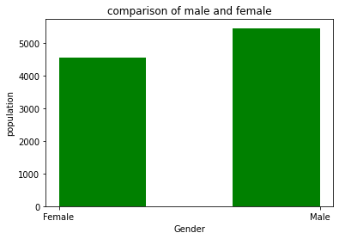
df['Age'].value_counts()
37 478
38 477
35 474
36 456
34 447
...
92 2
82 1
88 1
85 1
83 1
Name: Age, Length: 70, dtype: int64
# comparison of age in the dataset
plt.hist(x = df.Age, bins = 10, color = 'orange')
plt.title('comparison of Age')
plt.xlabel('Age')
plt.ylabel('population')
plt.show()
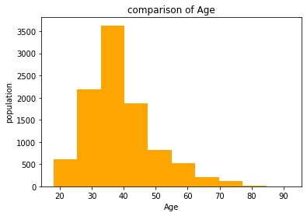
df['Geography'].value_counts()
France 5014
Germany 2509
Spain 2477
Name: Geography, dtype: int64
# comparison of geography
plt.hist(x = df.Geography, bins = 5, color = 'blue')
plt.title('comparison of Geography')
plt.xlabel('Geography')
plt.ylabel('population')
plt.show()
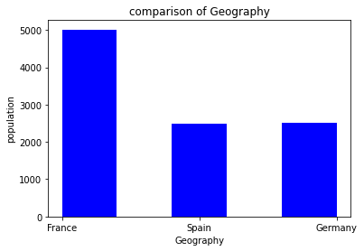
df['HasCrCard'].value_counts()
1 7055
0 2945
Name: HasCrCard, dtype: int64
# comparision of how many customers hold the credit card
plt.hist(x = df.HasCrCard, bins = 3, color = 'violet')
plt.title('how many people have or not have the credit card')
plt.xlabel('customers holding credit card')
plt.ylabel('population')
plt.show()
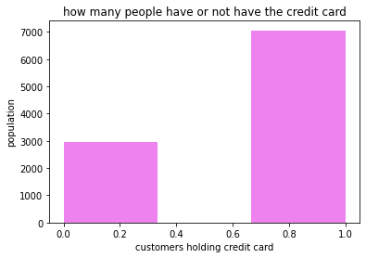
df['IsActiveMember'].value_counts()
1 5151
0 4849
Name: IsActiveMember, dtype: int64
# How many active member does the bank have ?
plt.hist(x = df.IsActiveMember, bins = 3, color = 'brown')
plt.title('Active Members')
plt.xlabel('Customers')
plt.ylabel('population')
plt.show()
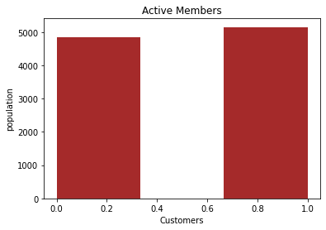

2. Bi - Variate Analysis
# comparison between Geography and Gender
Gender = pd.crosstab(df['Gender'],df['Geography'])
Gender.div(Gender.sum(1).astype(float), axis=0).plot(kind="bar", stacked=True, figsize=(6, 6))
<matplotlib.axes._subplots.AxesSubplot at 0x7f0f0d4da990>
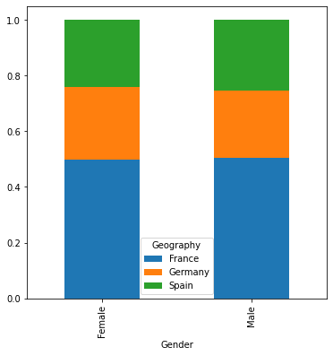
# comparison between geography and card holders
HasCrCard = pd.crosstab(df['HasCrCard'], df['Geography'])
HasCrCard.div(HasCrCard.sum(1).astype(float), axis = 0).plot(kind = 'bar',
stacked = True,figsize = (6, 6))
<matplotlib.axes._subplots.AxesSubplot at 0x7f0f0d40bb90>
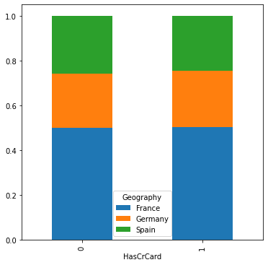
# comparison of active member in differnt geographies
IsActiveMember = pd.crosstab(df['IsActiveMember'], df['Geography'])
IsActiveMember.div(IsActiveMember.sum(1).astype(float), axis = 0).plot(kind = 'bar',
stacked = True, figsize= (6, 6))
<matplotlib.axes._subplots.AxesSubplot at 0x7f0f0d394110>
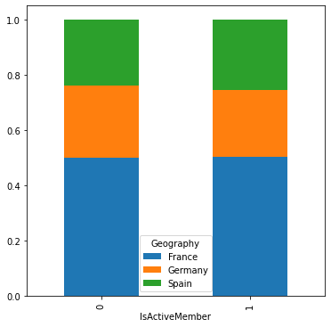
# comparing ages in different geographies
Age = pd.crosstab(df['Age'], df['Geography'])
Age.div(Age.sum(1).astype(float), axis = 0).plot(kind = 'bar',
stacked = True, figsize = (15,15))
<matplotlib.axes._subplots.AxesSubplot at 0x7f0f0d326690>
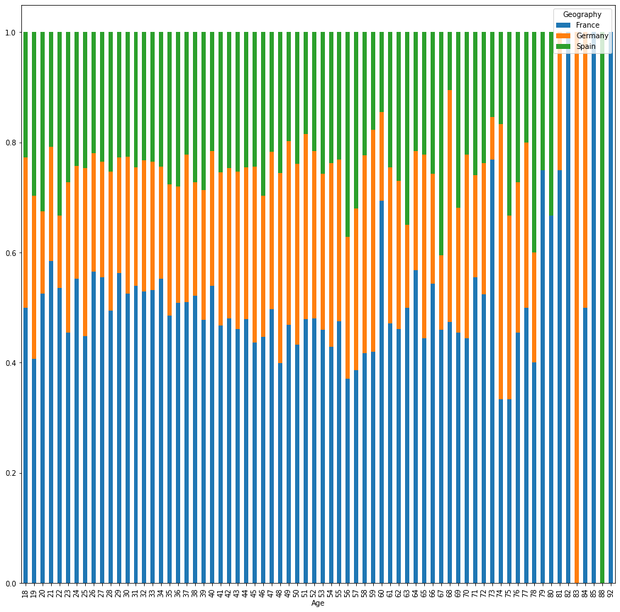
# calculating total balance in france, germany and spain
total_france = df.Balance[df.Geography == 'France'].sum()
total_germany = df.Balance[df.Geography == 'Germany'].sum()
total_spain = df.Balance[df.Geography == 'Spain'].sum()
print("Total Balance in France :",total_france)
print("Total Balance in Germany :",total_germany)
print("Total Balance in Spain :",total_spain)
Total Balance in France : 311332479.49
Total Balance in Germany : 300402861.38
Total Balance in Spain : 153123552.01
# plotting a pie chart
labels = 'France', 'Germany', 'Spain'
colors = ['cyan', 'magenta', 'orange']
sizes = [311, 300, 153]
explode = [ 0.01, 0.01, 0.01]
plt.pie(sizes, colors = colors, labels = labels, explode = explode, shadow = True)
plt.axis('equal')
plt.show()
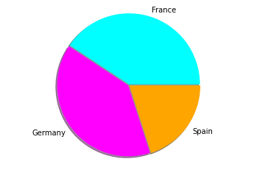

3. Multi - Variate Analysis
sns.pairplot(data=df, hue='Exited')
<seaborn.axisgrid.PairGrid at 0x7f0f0d201290>
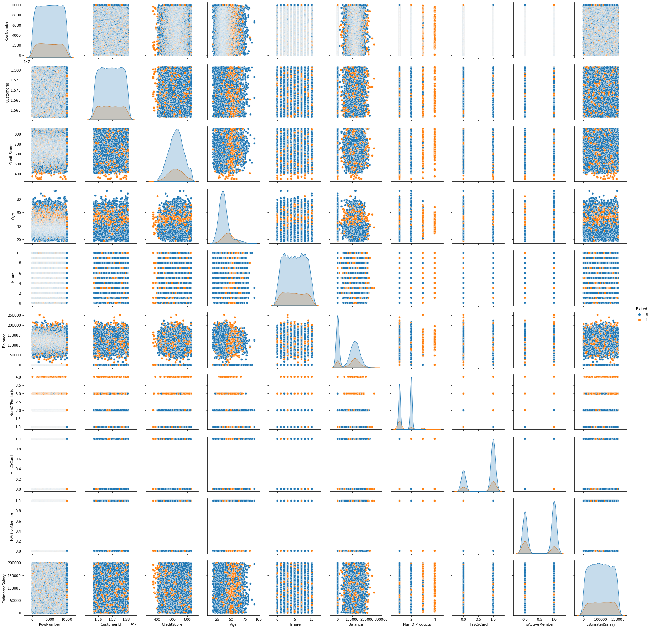

Descriptive statistics
df.describe()
RowNumber CustomerId CreditScore Age Tenure \
count 10000.00000 1.000000e+04 10000.000000 10000.000000 10000.000000
mean 5000.50000 1.569094e+07 650.528800 38.921800 5.012800
std 2886.89568 7.193619e+04 96.653299 10.487806 2.892174
min 1.00000 1.556570e+07 350.000000 18.000000 0.000000
25% 2500.75000 1.562853e+07 584.000000 32.000000 3.000000
50% 5000.50000 1.569074e+07 652.000000 37.000000 5.000000
75% 7500.25000 1.575323e+07 718.000000 44.000000 7.000000
max 10000.00000 1.581569e+07 850.000000 92.000000 10.000000
Balance NumOfProducts HasCrCard IsActiveMember \
count 10000.000000 10000.000000 10000.00000 10000.000000
mean 76485.889288 1.530200 0.70550 0.515100
std 62397.405202 0.581654 0.45584 0.499797
min 0.000000 1.000000 0.00000 0.000000
25% 0.000000 1.000000 0.00000 0.000000
50% 97198.540000 1.000000 1.00000 1.000000
75% 127644.240000 2.000000 1.00000 1.000000
max 250898.090000 4.000000 1.00000 1.000000
EstimatedSalary Exited
count 10000.000000 10000.000000
mean 100090.239881 0.203700
std 57510.492818 0.402769
min 11.580000 0.000000
25% 51002.110000 0.000000
50% 100193.915000 0.000000
75% 149388.247500 0.000000
max 199992.480000 1.000000

Handle the Missing values
df.isnull().sum()
RowNumber 0
CustomerId 0
Surname 0
CreditScore 0
Geography 0
Gender 0
Age 0
Tenure 0
Balance 0
NumOfProducts 0
HasCrCard 0
IsActiveMember 0
EstimatedSalary 0
Exited 0
dtype: int64

Find the outliers and replace the outliers
sns.boxplot(data = df, x = 'CreditScore')
<matplotlib.axes._subplots.AxesSubplot at 0x7f0f081e7490>
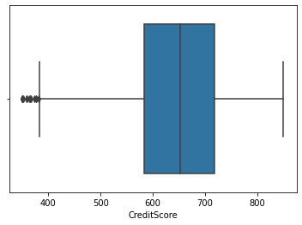
sns.boxplot(data = df, x = 'Age')
<matplotlib.axes._subplots.AxesSubplot at 0x7f0f082306d0>
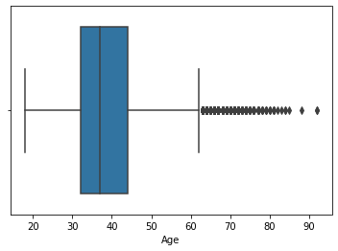
sns.boxplot(data = df, x = 'Balance')
<matplotlib.axes._subplots.AxesSubplot at 0x7f0f08f8d850>
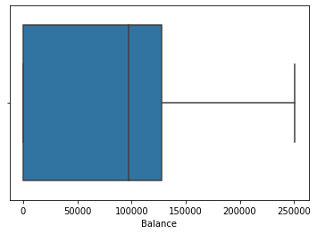
sns.boxplot(data = df, x = 'EstimatedSalary')
for i in df:
if df[i].dtype=='int64' or df[i].dtypes=='float64':
q1=df[i].quantile(0.25)
q3=df[i].quantile(0.75)
iqr=q3-q1
upper=q3+1.5*iqr
lower=q1-1.5*iqr
df[i]=np.where(df[i] >upper, upper, df[i])
df[i]=np.where(df[i] <lower, lower, df[i])
df.describe()
RowNumber CustomerId CreditScore Age Tenure \
count 10000.00000 1.000000e+04 10000.000000 10000.000000 10000.000000
mean 5000.50000 1.569094e+07 650.561300 38.660800 5.012800
std 2886.89568 7.193619e+04 96.558702 9.746704 2.892174
min 1.00000 1.556570e+07 383.000000 18.000000 0.000000
25% 2500.75000 1.562853e+07 584.000000 32.000000 3.000000
50% 5000.50000 1.569074e+07 652.000000 37.000000 5.000000
75% 7500.25000 1.575323e+07 718.000000 44.000000 7.000000
max 10000.00000 1.581569e+07 850.000000 62.000000 10.000000
Balance NumOfProducts HasCrCard IsActiveMember \
count 10000.000000 10000.000000 10000.00000 10000.000000
mean 76485.889288 1.527200 0.70550 0.515100
std 62397.405202 0.570081 0.45584 0.499797
min 0.000000 1.000000 0.00000 0.000000
25% 0.000000 1.000000 0.00000 0.000000
50% 97198.540000 1.000000 1.00000 1.000000
75% 127644.240000 2.000000 1.00000 1.000000
max 250898.090000 3.500000 1.00000 1.000000
EstimatedSalary Exited
count 10000.000000 10000.0
mean 100090.239881 0.0
std 57510.492818 0.0
min 11.580000 0.0
25% 51002.110000 0.0
50% 100193.915000 0.0
75% 149388.247500 0.0
max 199992.480000 0.0

Preprocessing
# Removing the unnecassary features from the dataset
data = df.drop(['CustomerId', 'Surname', 'RowNumber'], axis = 1)
print(df.columns)
Index(['RowNumber', 'CustomerId', 'Surname', 'CreditScore', 'Geography',
'Gender', 'Age', 'Tenure', 'Balance', 'NumOfProducts', 'HasCrCard',
'IsActiveMember', 'EstimatedSalary', 'Exited'],
dtype='object')
data.shape
(10000, 11)

Split the data into dependent and independent variables
# splitting the dataset into x(independent variables) and y(dependent variables)
x = df.iloc[:,0:10]
y = df.iloc[:,10]
print(x.shape)
print(y.shape)
print(x.columns)
(10000, 10)
(10000,)
Index(['RowNumber', 'CustomerId', 'Surname', 'CreditScore', 'Geography',
'Gender', 'Age', 'Tenure', 'Balance', 'NumOfProducts'],
dtype='object')

Check for Categorical columns and perform encoding
x = pd.get_dummies(x)
x.head()
RowNumber CustomerId CreditScore Age Tenure Balance NumOfProducts \
0 1.0 15634602.0 619.0 42.0 2.0 0.00 1.0
1 2.0 15647311.0 608.0 41.0 1.0 83807.86 1.0
2 3.0 15619304.0 502.0 42.0 8.0 159660.80 3.0
3 4.0 15701354.0 699.0 39.0 1.0 0.00 2.0
4 5.0 15737888.0 850.0 43.0 2.0 125510.82 1.0
Surname_Abazu Surname_Abbie Surname_Abbott ... Surname_Zubarev \
0 0 0 0 ... 0
1 0 0 0 ... 0
2 0 0 0 ... 0
3 0 0 0 ... 0
4 0 0 0 ... 0
Surname_Zubareva Surname_Zuev Surname_Zuyev Surname_Zuyeva \
0 0 0 0 0
1 0 0 0 0
2 0 0 0 0
3 0 0 0 0
4 0 0 0 0
Geography_France Geography_Germany Geography_Spain Gender_Female \
0 1 0 0 1
1 0 0 1 1
2 1 0 0 1
3 1 0 0 1
4 0 0 1 1
Gender_Male
0 0
1 0
2 0
3 0
4 0
[5 rows x 2944 columns]

Scale the independent variables
from sklearn.preprocessing import StandardScaler
sc = StandardScaler()
x_train = sc.fit_transform(x_train)
x_test = sc.fit_transform(x_test)
x_train = pd.DataFrame(x_train)
x_train.head()
0 1 2 3 4 5 6 \
0 -0.702176 -1.343330 -0.736828 0.042283 0.008860 0.673160 2.583231
1 -1.485722 1.558330 1.025257 -0.674496 0.008860 -1.207724 0.822578
2 -0.524522 -0.655156 0.808861 -0.469702 1.393293 -0.356937 0.822578
3 -1.167396 1.200594 0.396677 -0.060114 0.008860 -0.009356 -0.938076
4 -1.451159 0.778798 -0.468908 1.373444 0.701077 -1.207724 0.822578
7 8 9 ... 2934 2935 2936 2937 2938 \
0 -0.016332 0.0 -0.0231 ... -0.011548 0.0 -0.011548 -0.011548 -0.016332
1 -0.016332 0.0 -0.0231 ... -0.011548 0.0 -0.011548 -0.011548 -0.016332
2 -0.016332 0.0 -0.0231 ... -0.011548 0.0 -0.011548 -0.011548 -0.016332
3 -0.016332 0.0 -0.0231 ... -0.011548 0.0 -0.011548 -0.011548 -0.016332
4 -0.016332 0.0 -0.0231 ... -0.011548 0.0 -0.011548 -0.011548 -0.016332
2939 2940 2941 2942 2943
0 -1.015588 1.760216 -0.574682 1.087261 -1.087261
1 0.984651 -0.568112 -0.574682 1.087261 -1.087261
2 -1.015588 -0.568112 1.740094 1.087261 -1.087261
3 -1.015588 -0.568112 1.740094 -0.919743 0.919743
4 0.984651 -0.568112 -0.574682 -0.919743 0.919743
[5 rows x 2944 columns]

Split the data into training and testing
from sklearn.model_selection import train_test_split
x_train, x_test, y_train, y_test = train_test_split(x, y, test_size = 0.25, random_state = 0)
print(x_train.shape)
print(y_train.shape)
print(x_test.shape)
print(y_test.shape)
(7500, 2944)
(7500,)
(2500, 2944)
(2500,)

